**FILE COMPRESSION**

**ZIP**

**CREATE A ZIP ARCHIVE:**

* touch file{1..5}.txt
* zip comfile file1.txt file2.txt file3.txt file4.txt file5.txt

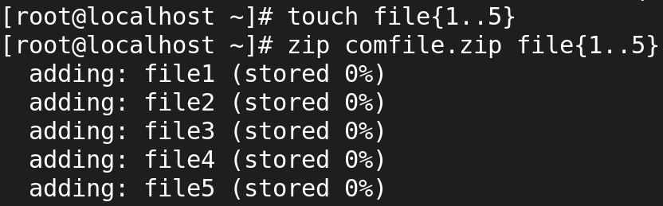

**LIST ZIP FILE CONTENTS:**

* zip -sf comfile

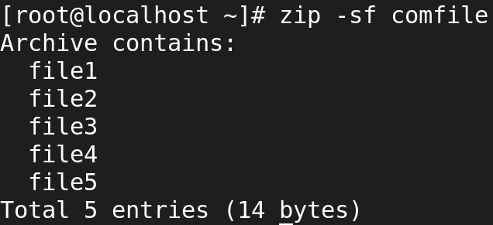

**ADD SPECIFIC FILE TYPES TO ZIP ARCHIVE:**

* zip files *.txt

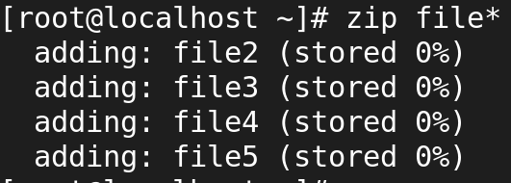

**ADD A DIRECTORY TO ZIP ARCHIVE:**

* zip -r files <directory>



**DELETE FILES FROM ZIP ARCHIVE:**

* zip -sf <archive file>
* zip -d <archive file> <files for deletion>
* zip -d files.zip file5.txt

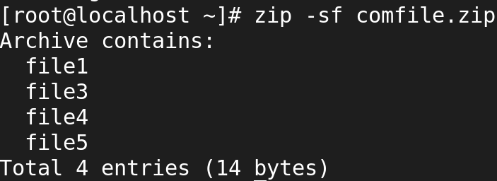

* fallocate -l 1G testfile
* zip test.zip testfile
* ls -lh

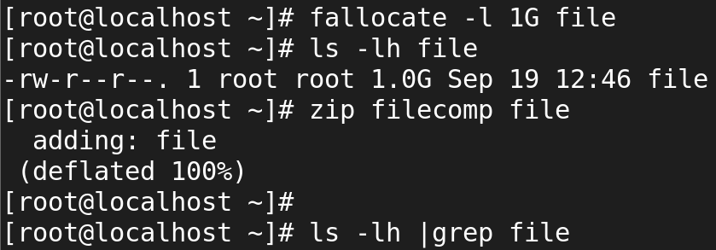

* unzip test.zip
* ls -lh

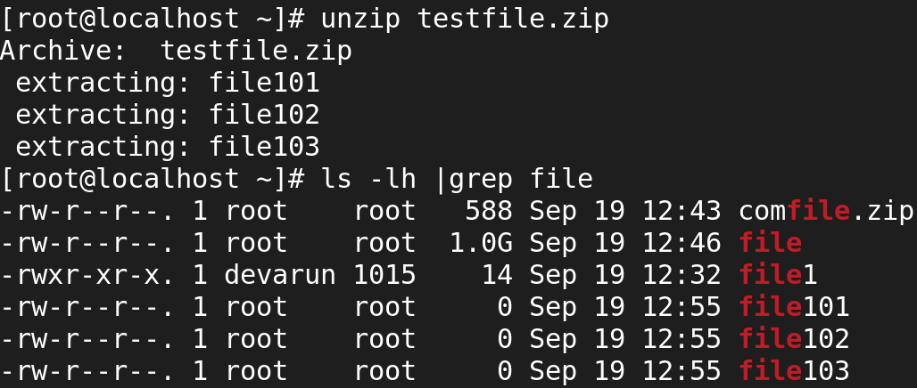

**GZIP**

* It compresses the file in the same file.
* It reduces the file size

To create normal file to be compressed

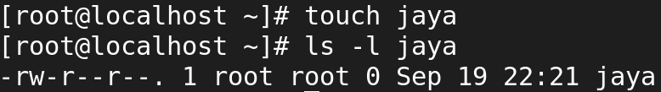

Compressing Files

* gzip filename



# Compress multiple files

* gzip file1 file2 file3 file4

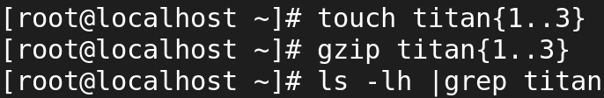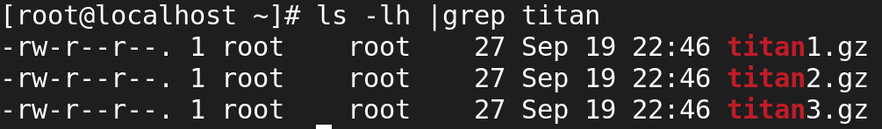

# Keep the original file

* gzip -k filename

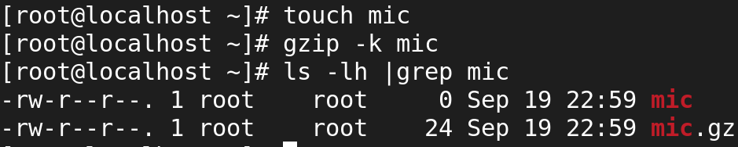

# Verbose output

* gzip -v filename

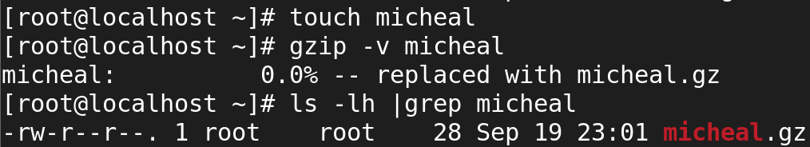

# Decompressing Files

* gzip -d filename.gz

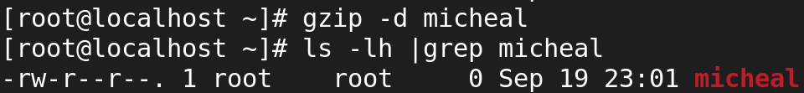

# Keep the compressed file

* gzip -dk filename.gz

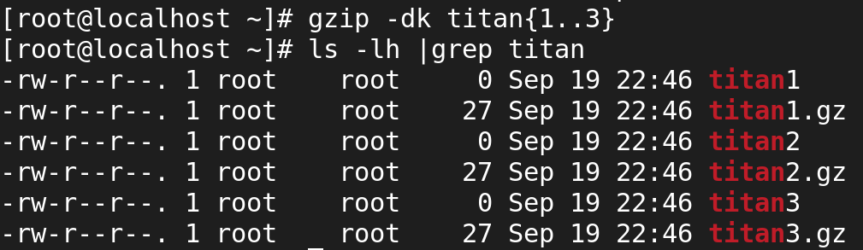

# TAR

# Create a tar Archive File in Linux

* tar -cvf etc-backup-19-09-2024.tar /etc

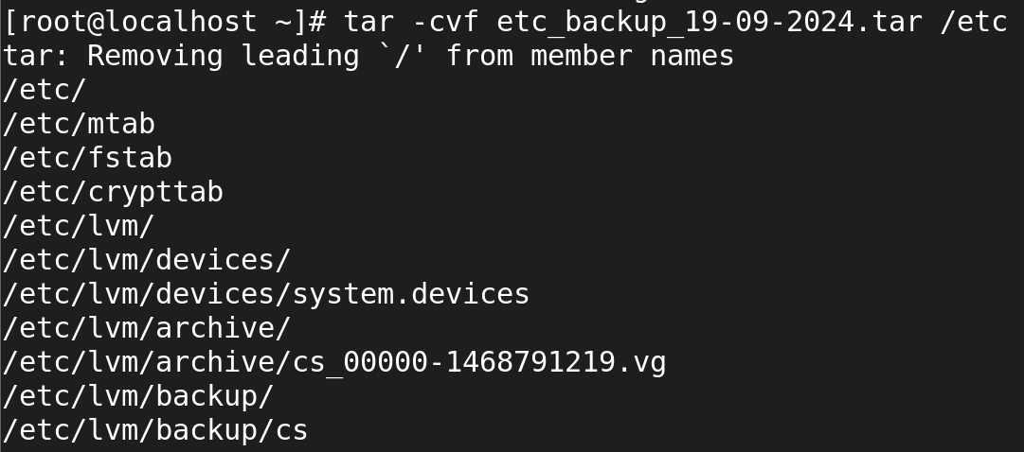

* c 🡪 Creates a new .tar archive file.
* v 🡪Verbosely show the .tar file progress.
* f 🡪 File name type of the archive file.

# Create tar.gz Archive File in Linux(Note: tar.gz and tgz both are similar).

* tar -cvzf etc-backup-14-09-12.tar.gz /etc

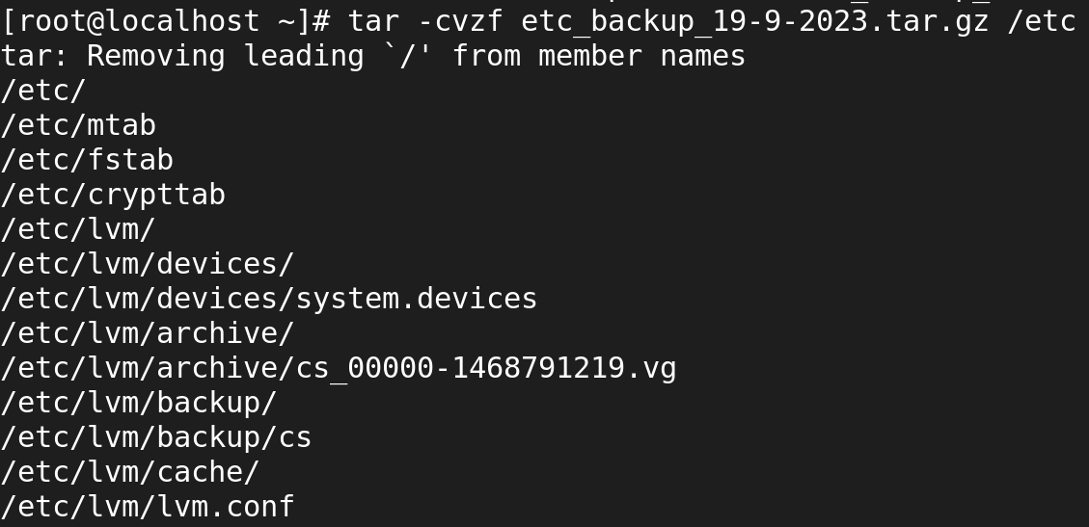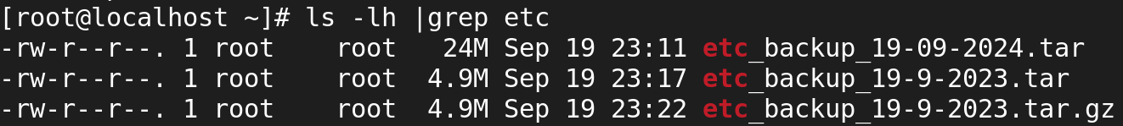

# Create tar.bz2 Archive File in Linux (Note: tar.bz2 and tbz is similar to tb2).

* tar -cvfj etc-backup.tar.bz2 /etc

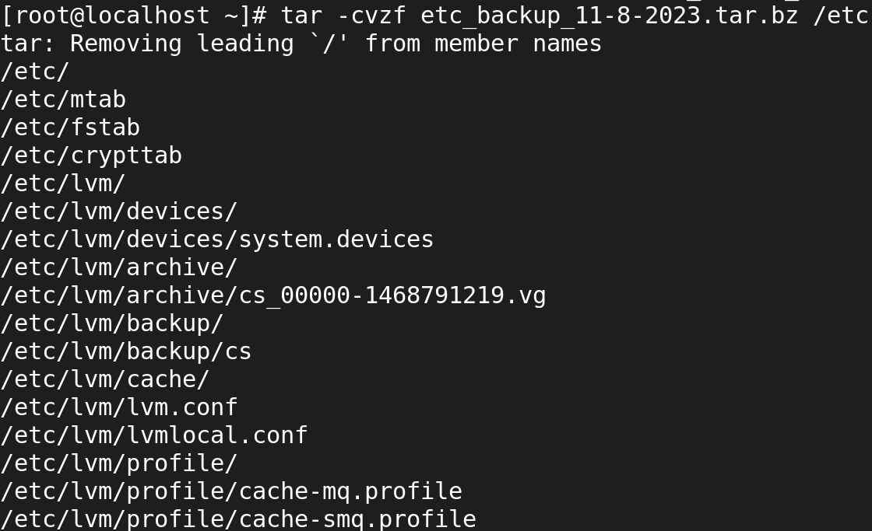

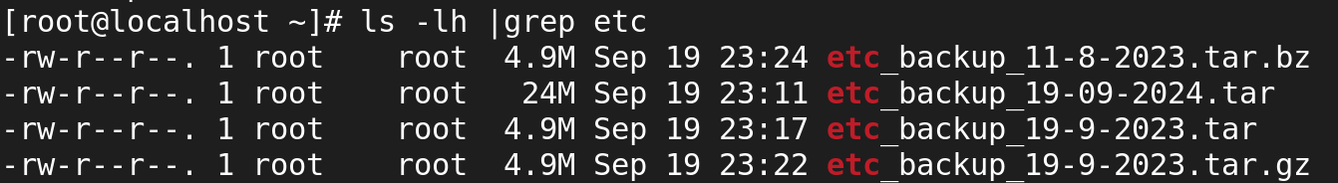

Untar tar Archive File in Linux (tar,tar.gz,tar.bz2)

* Untar files in Current Directory
* tar -xvf etc-backup.tar

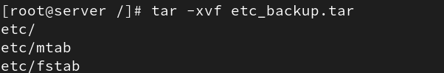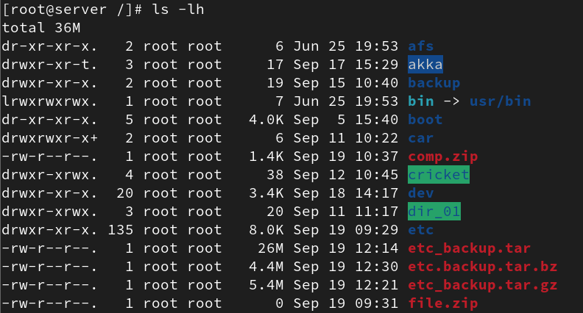

# Untar files in specified Directory

* tar -xvf etc-backup.tar -C /mnt

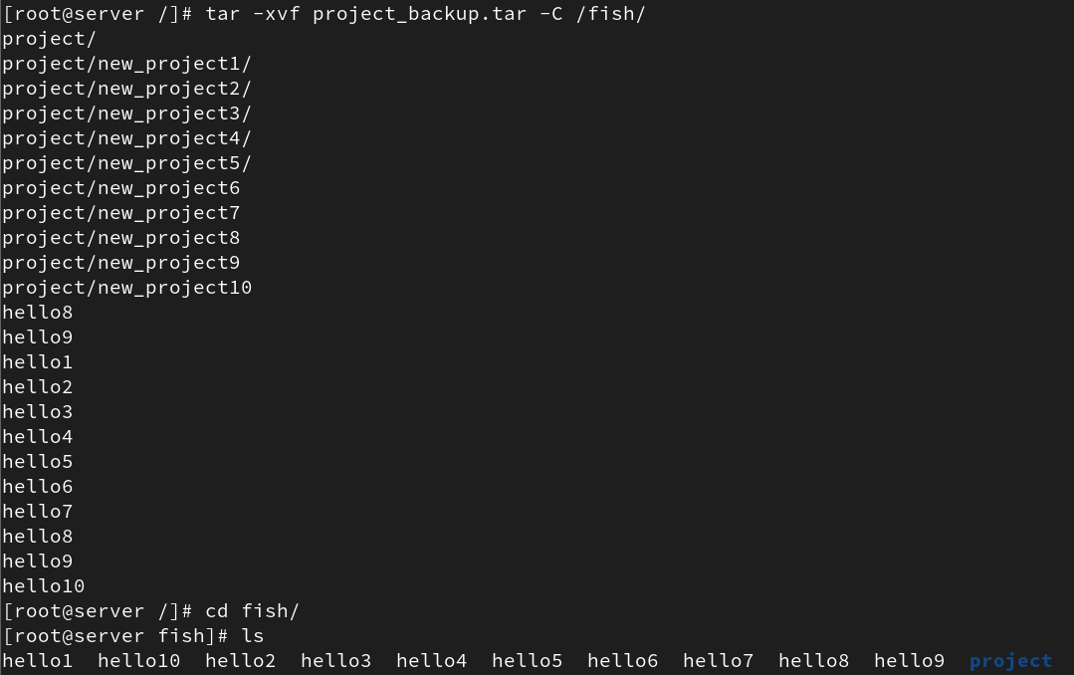

# Untar Single file from tar File in Linux

* Single file



# Multiple files from tar, tar.gz, and tar.bz2 File

* tar -xvf etc-backup.tar "passwd" "group"

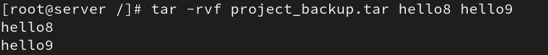

# List Content of tar Archive File in Linux

* tar -tvf backup.tar

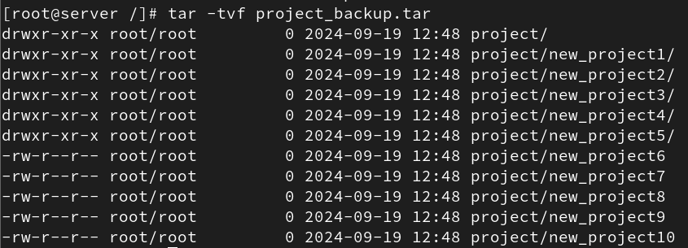

# Add Files or Directories to tar Archive File in Linux

* tar -rvf backup.tar file1 file2

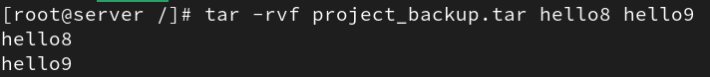

# Remove File and Directory from Tar Archive

* tar --delete -f backup.tar.gz file1.tx

